10/3/2018

I ran the “Verifying Correct Operation across the Operational Temperature Range” test (2.6).   In the chamber, the unit was chilled to 10c (50f) and then heated to 50c (122f) and then chilled back to 9c.    This is testing the Water Detection algorithm to make sure that a decrease of measured capacitance due to air heating (not water) will not cause an erroneous report of water.   The test passed.  No water was detected.

Besides running this test, I plunged the unit into water at 10c and 50c and it was correctly detecting water with the adjusted air and water targets.  The raw data shows all the minor adjustments to the targets over time. Without the adjustments, an increase of about 5 to 10C without pumping water could cause a false water report.

The following charts show the measured pad temperature versus the chamber temperature over time in seconds.   It took 83 minutes (5000 seconds) cycle the temperature from the lowest operating temperature to the highest.     This represents a worst case scenario.

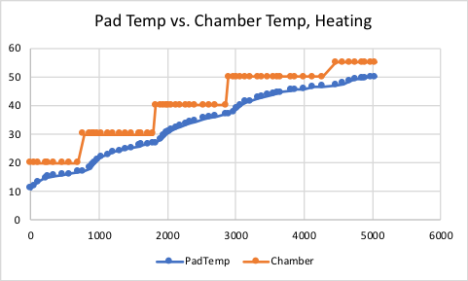

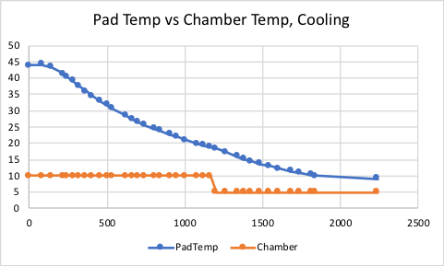

The raw data in temptests-oct3.txt shows the debug trace collected while running the test.   The entries shows how the air and water targets are adjusted when the air temperature over the pads changes.   The target capacitance values go up when the temperature goes down and vice versa.

The excel file is the source of the charts.

Best Regards,

**Robert Lieb**

Principal Software Engineer

[http://intelligentproduct.solutions](http://www.intelligentproductsolutions.com/)

700 Veterans Highway, Suite 100, Hauppauge, NY 11788